Design Document
Flock of Birds System

Mark Krijgsman Peter Curet



Delft
November 12, 2008

Index

Index 1
1 Introduction 2
2 Overview 3
2.1 Main Design Description 3
2.2 Design Decisions 3
3 Packages 4
3.1 Main 4
3.2 Reader 4
3.3 GUI 5
4 State Machine 7
5 Classes 8

Introduction

In this document we will describe the design of the existing Flock of Birds (FoB) application. Because the source code will be released as open source, it is important to document the existing system design in English to increase its accessibility. Furthermore, changes and design decisions that we have made concerning the existing design will be further elaborated on.
In the next chapter we will discuss the main design elements of the application. We will also elaborate on the design decisions we have made to further improve on the application. In the third chapter we will discuss the main packages in which the software can be split up in. In the fourth chapter we will talk about the state machine architecture of the software, and in the last chapter we will elaborate on the complete code architecture by updating the class diagram and discussing class descriptions.

Overview

In this section we will give a summarized description of the main components and ideas of the application. Furthermore, we will discuss our main decisions concerning changes we have made to the previous design.

Main Design Description
As we are working on an existing application, our main objective is to maintain the existing ideas of the previous design, and further improve on them where necessary. Because changes have been made in the code, it is important to document the progress, analyse the changes, and to update the corresponding design diagrams.

The main design can be split up into four packages, each having a distinct function. The main package, the reader, the GUI and the visualizer. Furthermore, a state machine design pattern is utilised. This state machine pattern implies that the program can be in one of the defined states, each with different functionality. Each state corresponds with a panel that the GUI can display.

Design Decisions
One of our main objectives is making the code more generic. This decision implies removing any hardcoded elements existent in the code. Resulting from this, more advanced users will be able to modify and add configurations through the configuration.ini file. The application needs to be able to accept and process these changes.

One of the dilemmas we have faced is the possibility of having an option for advanced functionality for the users. Although we have developed this idea in our requirement analysis document, we have decided on excluding it from the design, leaving the advanced functionality as an optional goal. Instead we will focus our efforts on the functionality mentioned earlier of modifying the configuration file, a non-GUI method for modifying configurations for advanced users. This exclusion will benefit the visibility of designed diagrams, preventing unnecessary clutter.

Furthermore, we want to further the possibility of connecting different hardware such as OptoTrak to the application. This will be done by allowing separate driver classes, each for the specific hardware, to be connected to the software. An interface hardware driver will be added to the design, allowing the specific hardware driver such as the FoBDriver to inherit basic functions. These primary functions will allow the main driver to retrieve sensor information from different hardware drivers in a consistent way. The backend however, will be a hardware specific implementation of the actual link between the hardware and software. Currently, hardware specific code is used in the main driver. Migrating misplaced GH estimation methods from the driver to the FoBDriver will be essential. Furthermore many mathematical Matlab methods in Driver are unused and can be moved to the driver unused function file.
Throughout the application several class, variable and method names possibly causing misunderstandings have been changed, improving readability of the code.
Furthermore, a consistent checking method will be added for each state class assuring the correctness of each step made by the user.

Packages

The design of the software can be looked at as consisting of several separated packages. Each package consists of classes serving one function as a whole. Figure 1 displays a diagram containing the main idea of the packages.

3.1 Main
The main package contains the classes which form the core of the program, and control the entire process. This is done through a state machine design pattern described in the next section. Each state corresponds with a GUI package panel classes. This allows the graphical elements to be separated from the functional elements.

To improve on the clarity of this package design, the state entities RecordingState and PlaybackState in the main package have been displayed as one entity inside the VisualizationState. The RecordingState and PlaybackState were previously named RealtimeState and RecordingState in consecutive order. During the process of requirement analysis and designing, the conclusion was made that these names were inappropriate, as they caused several misunderstandings. The RealtimeState has now been renamed to RecordingState, as this is were the actual process of recording takes place. The RecordingState has been renamed to PlaybackState as the playback of movements takes place in that state. These changes will be carried out in the corresponding GUI classes as well.

Classes of the Main package communicate with both the GUI package and the Reader package.

3.2 Reader
The reader classes handle the input and processing of information. The PreferencesFileReader and the ConfigFileReader handle data concerning the settings of the application.

In the previous version of the application, functionality existed for opening and saving of previous measurement and recording sessions. These functionalities have been taken out of the current design, as they were only necessary for the simulation of sessions in the previous version of the application. As we are only keeping the functionality of importing previously recorded movements, the FileLoader class will be replaced by a RecordingsManager class, which will only contain functionality for importing and exporting of movement data.

The driver handles the communication with the hardware and processing of the measurement data. It does this through the hardware specific drivers, for example, the FoBDriver. This driver will handle communication with the actual FoB hardware. We will be using a FakeFob class to simulate the hardware. When using other hardware such as the OptoTrak, an OptoTrak driver can be made and the Driver class will have to be adjusted to use it as the hardware driver. In the new design, each specific driver is implemented using an Interface class called HardwareDriver, to make sure all specific drivers will maintain a consistent implementation pattern with the same basic functionality.

3.3 GUI
This package handles the graphical elements of the program. Each screen of the program has a separate class. Several dialog menu’s can also be found in the GUI package.

In previous design diagrams the GUI was displayed as being connected to the reader package. We believe however, that the GUI package needs to be separated and have the main package handle all communication with the reader package.

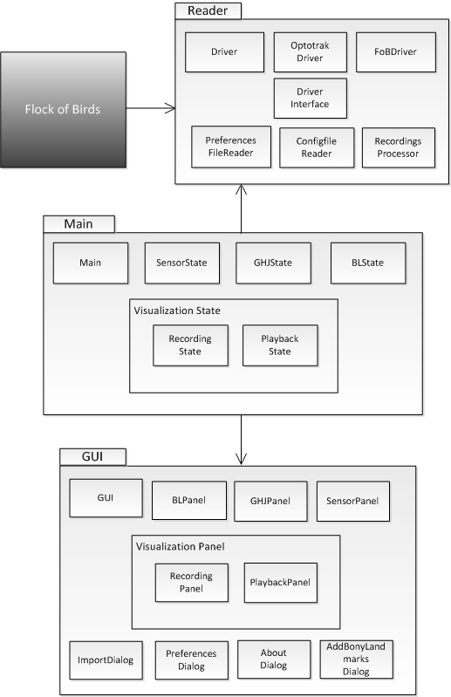

Fig. 1 A package diagram of the FoB visualizer

State Machine

One of the main design concepts prevailing throughout the code architecture is that of the state machine. We will maintain this design philosophy and apply it when further developing the software. Figure 2 displays the state machine design pattern of our application

The application is designed in such a way that the program is constantly in one of four states. The application allows going forward through the states whenever the necessary parameters are correct. Going forward through this path can only be done one state at a time. When residing in one of the later states however, the program can go back to any of its earlier states. Furthermore, each state has a separate corresponding GUI panel.
The Visualization state has two sub-states not displayed in figure 2, namely the recording state and the playback state.

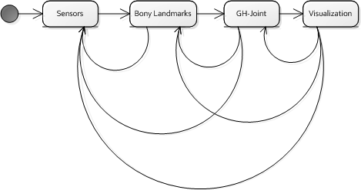

Fig. 2 A State machine diagram of the FoB visualizer

Classes

In the following section we will elaborate on the the design using class diagrams.
In figure 3 a summarized version of the class diagram is shown. Here the associations are clarified. For this version of the class diagram we included the HardwareDriver interface and let the OptotrakDriver and FoBDriver inherit from it.
Furthermore, the set of visualization panels and states have been reorganized.
In the previous version, the design showed the visualization sub-panels and states as only being accessible through the VisualizationState whereas in the updated diagram the sub-panels are connected to the VisualizationPanel, and the sub-states are connected to the VisualizationState. This was done to further consistent separation of the GUI classes from the State classes.

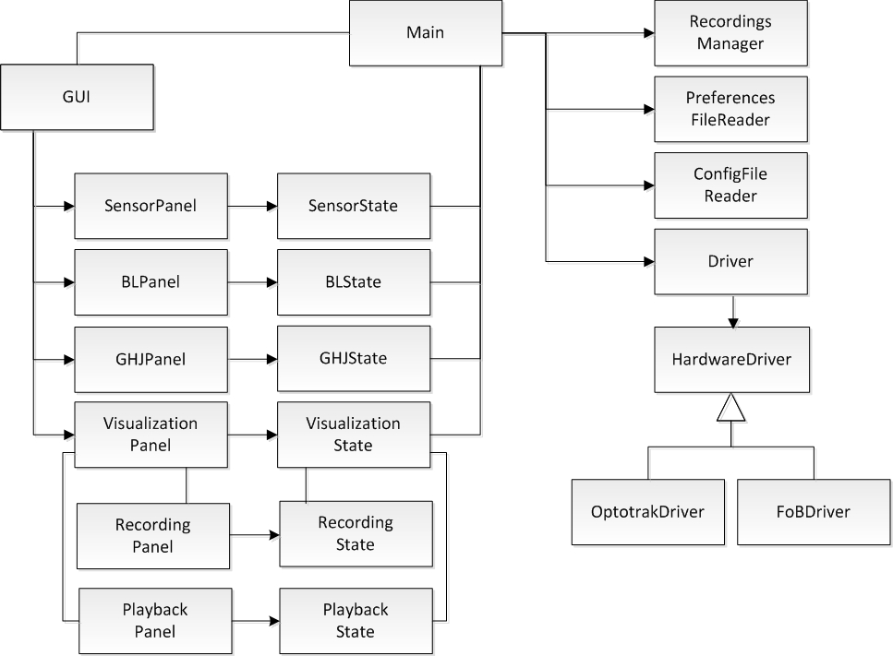

Fig. 3 A diagram of the important classes

